CHAPTER ONE
GENERAL INTRODUCTION

1.1 INTRODUCTION
Blood Bank Management System are responsible for the safe and efficient collection, processing, testing, storage, and distribution of blood product. Traditionally, blood management was often fragmented, with various departments handling different stages of the process independently. This led to inefficiencies, errors, and potential risks. A modern Blood Bank Management System seeks to overcome these limitations by providing a holistic and coordinated framework for managing blood resources. The purpose of a Blood Bank Management System is to ensure a readily available supply of blood to patients.
1.2. BACKGROUND OF THE STUDY
The history of Blood Bank Management System where mostly characterized by a manual system processes. Where blood collection, processes and storage were largely undocumented therefore posing a risk for both donors and recipients. Also blood typing crossmatching and transfusion record were meticulously documented on paper, these records mostly had errors, therefore making it difficult to track and face challenges to retrieve efficiently. With the advancement of technology the Blood Bank Management System comes in to improve the manner in which blood is being handle either by processing, storage, testing, distribution of these blood to patients who are in need. hence improving patient safety.
1.3 PROBLEM STATEMENT
Blood is an essential medical resource required for surgeries, accident emergencies, childbirth complications, and the treatment of diseases such as anemia and cancer. An efficient blood bank management process is expected to ensure accurate donor registration, proper blood storage, quick retrieval of blood information, and timely distribution of blood units to hospitals and patients. In an ideal healthcare environment, blood bank operations should be computerized to improve data accuracy, reduce delays, enhance communication between donors and recipients, and maintain safe records of blood availability and transfusion history.
However, many blood banks and hospitals still rely on manual or partially computerized systems for managing donor information and blood inventory. This often leads to problems such as loss of records, duplication of donor data, delays in locating compatible blood groups, and poor monitoring of blood stock levels. According to the World Health Organization, millions of blood donations are collected globally every year, yet many developing healthcare systems continue to face shortages and inefficient management due to poor record-keeping and limited digital infrastructure. Manual management methods increase the risk of human error, inaccurate reporting, and delayed emergency response, which can endanger patients’ lives.
Therefore, the objective of this research is to design and implement a Blood Bank Management System that will automate donor registration, blood inventory management, blood request processing, and report generation. The proposed system aims to improve efficiency, accuracy, security, and accessibility of blood bank records while reducing human errors and delays in blood distribution.
1.4 OBJECTIVE OF THE STUDY
This study has a general objective and some specific objective.
1.4.1 General Objective
The general objective of this study is to design and implement a Blood Bank Management System that will improve the management, storage, and distribution of blood and donor information through a computerized platform. The study aims to enhance the efficiency of blood bank operations by reducing manual processes, improving data accuracy, and ensuring quick access to blood information during emergency situations. The system is also intended to provide a reliable and secure means of managing blood donations, blood requests, donor records, and inventory activities within healthcare institutions.

1.4.2 Specific Objective
These study include developing a system for registering and managing blood donor information, creating a centralized database for secure storage and retrieval of records, and monitoring blood stock levels and blood group availability in real time. The study also aims to facilitate quick searching and matching of compatible blood groups, reduce paperwork and human errors, improve communication between donors and hospitals, and generate reports related to blood donations and blood inventory. In addition, the system seeks to enhance data security, improve emergency response efficiency, and provide a user-friendly platform for managing blood bank activities effectively
1.5 SIGNIFICANCE OF THE STUDY
1 To the students
This study is important because it provides knowledge and practical understanding of how computerized systems can be used to solve real-life problems in the healthcare sector. Through the development of a Blood Bank Management System, students gain experience in system analysis, database design, programming, and software development techniques. The study also helps students understand the importance of information technology in improving healthcare services, data management, and decision-making processes.

2 To Landmark Institution
Landmark can collaborate with local blood bank to organize blood donation camps, ensuring a steady supply for emergencies. Incase of accident like sport injuries or lab accident having a connection with blood bank ensure quick access to if needed.
Medical student can learn more about blood group types, donation processes and inventory management in healthcare which helps to create programs about blood donation and its importance.
Landmark can partner with hospital, blood banks and software companies that use BBMS to provide internship and job opportunities for their student.
1.6 SCOPE OF THE STUDY
The foundation of a BBMS lies Donor Management. This function goes beyond mere data entry, encompassing the entire donor lifecycle. It meticulously records demographic information, contact details, and crucially, a comprehensive medical history of each potential donor. This detailed profile serves as the basis for Donor Screening, a rigorous process that assesses eligibility based on pre-defined criteria, encompassing medical history, physical examinations, and risk factor assessment for transfusion-transmissible infections. Integration with electronic health records and automated questionnaires further streamlines this process, reducing manual effort and potential errors. When donors are deemed ineligible, the Donor Deferral Management module steps in, meticulously tracking both temporary and permanent deferrals based on conditions like medications, travel history, or identified health risks.
Blood Bank Management System (BBMS), represents a comprehensive and intricate ecosystem designed to orchestrate every facet of blood banking operations. Moving far beyond simple data storage, a BBMS seeks to improve the way blood banks function, ensuring safety, efficiency, and ultimately, saving lives. Spanning from the initial donor interaction to the final transfusion, a well-defined BBMS encapsulates a multitude of interwoven functionalities, seamlessly connecting various departments and processes within the blood bank and its affiliated healthcare network.
1.7 DEFINATION OF TERMS
• Blood Bank Management System (BBMS): A software system designed to manage all aspects of blood bank operations, from donor recruitment to patient transfusion.
• Transfusion: The process of administering blood or blood components to a patient.
• Blood Product: A component of blood (e.g., red blood cells, plasma, platelets) that has been separated from whole blood for therapeutic use.
• Unit: A specific quantity of a blood product collected from a single donor.
• Lot Number: A unique identifier assigned to a batch of blood products processed together.
• Donor: An individual who voluntarily donates blood.
• Whole Blood: Blood collected directly from a donor without separating the components.
• Apheresis: A process in which blood is drawn from a donor, one or more components are separated, and the remaining components are returned to the donor.
• Donor Screening: The process of evaluating a potential donor's eligibility to donate blood based on medical history, physical examination, and risk factors.
1.8 ORGANISATION OF THE STUDY
This study is organized into five chapters. Chapter One presents the general introduction, which incudes the background of the study, statement of the problem, objectives of the system, scope of the study definition of key terms and the organization of the study. Chapter Two focuses on the literature review, covering the introduction, review of related concepts, review of related works and the proposed system. Chapter Three discusses the materials, tool and methods used in the study, including the development methodology, system tools and materials system modules and system design. Chapter Four present the implementation, result and testing of the system, including implementation procedures, results obtained and testing strategies used to evaluate the system. Finally, Chapter Five provides the summary of findings, conclusion, recommendations and perspectives for further studies.

CHAPTER TWO
LITERATURE REVIEW
2.1 Introduction
Blood Bank management systems play a critical role in the society and healthcare domain by ensuring the safe and efficient collection, storage, distribution, and transfusion of blood products. Back in the days blood banking focused primarily on basic blood type and storage, lacking sophisticated tracking and management system. Blood transfusions were often risky due to limited understanding of compatibility and infection control hence these causes a lot of death. With the introduction of modern technology this situation can be better handle with care by focusing on technological advancements, operational challenges, and innovative solutions being implemented worldwide. Blood Bank Management System is important for a multiple of reasons like it help minimize the risk of administering the wrong blood type of a patient, reduces blood wastage enable tracking of blood inventory levels, expiration dates and storage condition.
2.2 Review of Related Concepts
We are going to look at concepts that are related to blood bank management system: These include;
2.2.1 The Concept of Blood Bank Management System
A Blood Bank Management System (BBMS) is a computerized information system designed to manage and monitor blood donation activities, donor records, blood inventory, blood requests, and transfusion processes within hospitals and blood banks. The system helps healthcare institutions automate manual operations, improve data accuracy, and ensure quick access to blood-related information during emergencies. A BBMS normally includes modules such as donor registration, blood collection, blood screening, blood storage, stock monitoring, and report generation.
According to the World Health Organization, proper blood management systems are important for maintaining safe and sufficient blood supplies for patients requiring transfusion services. Computerized systems also reduce paperwork, minimize human errors, and improve communication between donors, hospitals, and blood banks.
2.2.2 Database Management in Blood Banks
Database management is one of the core concepts in a Blood Bank Management System. A database stores and organizes donor information, blood group details, screening results, and inventory records in a structured format. Database Management Systems (DBMS) such as MySQL and Oracle Database are commonly used in BBMS development because they support efficient storage, retrieval, updating, and security of data.
Using a database improves data consistency, prevents duplication of records, and allows authorized users to access information quickly. Database technology also supports backup and recovery mechanisms, which are essential for maintaining reliable healthcare records. Ramez Elmasri & Shamkant B. Navathe (2016). Fundamentals of Database Systems.
2.2.3 Donor Management System
Donor management is another important concept related to BBMS. It involves maintaining records of blood donors, including personal details, blood groups, donation history, medical screening results, and contact information. The purpose of donor management is to ensure that eligible donors can easily donate blood and be contacted when specific blood groups are required.
A computerized donor management system helps improve communication with donors through notifications and reminders for future donations. It also helps identify voluntary donors and maintain accurate donor eligibility records. World Health Organization. Towards 100% Voluntary Blood Donation.
2.3 Review of related work
1.Web-Based Blood Bank Management System
The Web-Based Blood Bank Management System is a computerized system developed to facilitate the management of blood donation and distribution activities through an online platform. The system allows donors, hospitals, and administrators to interact efficiently over the internet. Donors can register, update their personal profiles, and access donation information, while hospitals can search for available blood types and submit blood requests online. According to Santosh Ks and Anjali Verma (2025), the system was developed using technologies such as PHP, MySQL, HTML, CSS, and JavaScript. One major strength of the system is its accessibility since users can access the platform from any location with an internet connection. The system also improves communication between donors and recipients, especially during emergencies, while reducing paperwork and speeding up the process of locating compatible blood. However, the system heavily depends on stable internet connectivity, which may not always be available in some regions. In addition, storing sensitive donor information online raises concerns about data security and privacy. The authors recommended implementing stronger encryption methods, secure authentication mechanisms, and offline support features in future versions of the system to improve reliability and enhance data protection.
2.Cloud-Based Blood Bank Information System
The Cloud-Based Blood Bank Information System is a modern blood management system developed to improve the storage, management, and sharing of blood bank information through cloud computing technology. According to Abhilash Sharma and R. Gupta (2023), the system was developed using cloud computing platforms such as Amazon Web Services and Firebase together with web technologies. One of the major strengths of the system is its scalability and high availability, which allow users to access the system from different locations at any time. The system also supports real-time updates, which are highly important during emergency situations requiring urgent blood supply. In addition, the cloud-based structure enables collaboration among multiple hospitals and blood banks, thereby improving the efficiency of blood distribution and management. However, the system relies heavily on stable internet connectivity, which may be difficult to maintain in rural or underdeveloped regions. Furthermore, storing sensitive medical data on cloud platforms introduces cybersecurity and privacy risks. The authors recommended the implementation of advanced security measures such as data encryption, multi-factor authentication, regular system audits, and backup mechanisms to improve data protection and prevent information loss in future developments.
3. Comprehensive Blood Bank Management System
The Comprehensive Blood Bank Management System developed by Ishat Khan and M. Ali (2024) is a desktop-based system designed to manage various blood bank operations within large healthcare institutions. The system was developed using C#, .NET Framework, and Microsoft SQL Server. One of the major strengths of the system is its comprehensive functionality, which integrates multiple blood bank operations into a single platform, thereby improving workflow efficiency and reducing manual processes. The system also provides structured data management and detailed reporting features that assist administrators in making informed decisions regarding blood inventory and donor management. However, because the system is desktop-based, it lacks remote accessibility and cannot easily support collaboration or integration with other hospitals and national healthcare systems. In addition, the system does not provide real-time updates, which may limit efficiency during emergency situations. The authors recommended redesigning the system into a web-based or cloud-integrated platform with interoperability features to improve accessibility, communication, and real-time data sharing in future developments.
4.Online Blood Bank Management System
The Blood Bank Management System with Inventory Optimization developed by Dipali Khairnar and S. Kulkarni (2024) is a system designed to improve blood bank operations through efficient inventory management and optimization techniques. The system was developed using Python, SQL databases, and optimization algorithms to help manage blood stock levels and reduce wastage caused by expired blood units. By applying optimization methods, the system improves the allocation and distribution of blood resources, making blood availability more efficient during emergencies. However, the complexity of the system makes it difficult to implement and maintain, especially in smaller healthcare facilities with limited technical expertise and infrastructure. In addition, the system may require higher computational resources, which can increase operational costs. The authors recommended simplifying the system interface, developing a more user-friendly dashboard, and providing adequate training for healthcare staff to improve usability and accessibility in future implementations.
5.Blood Bank Management System with Inventory Optimization
The Online Blood Bank Management System developed by Vedanti Deshpande and P. Joshi (2020) is a web-based system designed to improve access to blood bank services through an online platform. The system was developed using ASP.NET and Microsoft SQL Server. The system allows users to view blood availability, register as donors, and access blood bank services online. One of its major strengths is the centralized database structure, which makes it easier to manage and share information across different departments while ensuring that data remains consistent and up-to-date. The system also improves efficiency by reducing the time required to locate compatible blood during emergencies and enhances coordination between donors and recipients. However, the system lacks real-time tracking and advanced functionalities such as automatic donor-recipient matching, limiting its ability to respond quickly during critical situations. The authors recommended integrating real-time update features, GPS-based donor tracking, and intelligent matching systems to improve system responsiveness and overall efficiency in future developments.
2.4. PROPOSED SOLUTION
a. Awareness Campaigns
Use social media, community events, schools, and workplaces to raise awareness about the importance of blood donation. And also Collaborate with influencers and local leaders to promote donation drives.
b. Mobile and Web Platforms
Develop easy-to-use apps and websites where potential donors can register and create profiles, Check eligibility based on health and donation history, Find nearby donation centers or mobile camps and Schedule appointments to avoid long wait times.
c. Inventory Management
Use barcode/RFID tagging for blood units to track location and status. Moreso Integrate inventory database with alert system and Dashboard for staff to monitor stock levels and generate reports.

CHAPTER THREE
MATERIALS AND METHODS USED
3.1 INTRODUCTION
To successfully build this Blood Bank Management system, there are some essentials materials that must be used. This chapter outlines the techniques, materials and explains the various modules of the project in depth. A clear description of these techniques and modules is essential for the growth of the project as it ensures the application meets user, stakeholder and organization needs. By identifying and outlining this, we aim to highlight and show case how each tool contributes to the project success and to make it efficient and effective. This also ensures that the product developed meets the expected standards and provides a comprehensive solution that effectively addresses user needs.

3.2. DEVELOPMENT METHODOLOGY USED
A methodology is a system of methods which has structured procedures and techniques used to identify and analysis information regarding a topic for bringing about a certain goal. The methodology used in the design and implementation of a Blood Bank Management system is the agile methodology. This methodology is further discussed below.

3.2.1. Agile Methodology
Agile methodology is an iterative approach to software development and project management that emphasizes flexibility, collaboration, customer feedback, and rapid delivery of small, incremental changes. Unlike traditional project management methods, which often involve long, linear development cycles, Agile focuses on creating a dynamic process that can quickly adapt to changing requirements and feedback. Some key practices and techniques are:
- Scrum: Scrum is one of the most widely used Agile frameworks. It divides the development process into fixed-length iterations called sprints, which usually last two to four weeks. A Scrum team typically includes roles such as the Product Owner, Scrum Master, and Development Team. Scrum emphasizes daily stand-up meetings, sprint planning, sprint reviews, and retrospectives.
- Kanban: Kanban focuses on visualizing the workflow and limiting work in progress to improve efficiency. It uses a Kanban board to track the status of tasks and ensure a smooth flow of work.
- Extreme Programming (XP): XP is an Agile methodology that emphasizes technical excellence and good programming practices. Key practices include pair programming, test-driven development, and continuous integration

3.3. TOOLS AND MATERIALS USED
For the design and implementation of this system, both hardware and software components are required to streamline the process. The various hardware and software tools that were used in the system are outlined below:

3.3.1. Hardware Requirements
Here, we’ll look at some key hardware components to consider when designing, developing and deploying this system.
1. Servers Infrastructure:
• Database Server: This is the most critical server, responsible for storing and managing the BBMS database.
- Processor: Intel Xeon, AMD EPYC with at least 8 cores,
- RAM: At 16 GB of RAM for small and 32 GB for larger ones.
- Storage: At least 500GB to 1TB is needed.
- Network Interface Card (NIC): A Gigabit Ethernet or faster for high-speed network connectivity.
2. Client Workstations:
- Processor: Intel Core i5 or equivalent AMD processor.
- RAM: At least 8 GB of RAM.
- Storage: SSD with at least 256 GB.
- Monitor: At least a 19-inch monitor with a resolution of 1366x768 or higher. Dual monitors can improve productivity.
- Operating System: Windows 10/11, Linux, or macOS.
- Web Browser: Chrome, Firefox, Edge.
3. Barcode Scanners:
- Handheld Barcode Scanners: For scanning blood units, donor IDs, and patient IDs. Choose scanners that support 1D and 2D barcodes. Wireless scanners can improve mobility.
- Barcode Printers: For printing labels for blood units, sample tubes, and other items. Direct thermal or thermal transfer printers are recommended.
3.3.2. Software Requirements
The development of a Blood Bank Management System requires several software tools and technologies to support system analysis, design, programming, database management, testing, and deployment. These software requirements help ensure that the system operates efficiently, securely, and reliably in managing blood bank activities such as donor registration, blood inventory management, blood requests, and report generation
The Operating System
An operating system is required to provide the environment in which the system will run. Commonly used operating systems include Microsoft Windows and Linux. Programming languages such as PHP, Python, Java, or C# are used to develop the application logic and functionalities of the system. For database management, software such as MySQL, Microsoft SQL Server, or Oracle Database is required to store and manage donor records, blood inventory, and hospital information securely.
- MySQL: A popular open-source RDBMS, offering a strong balance between features, performance, and ease of use. It is well-suited for many BBMS applications, particularly smaller to medium-sized installations.
- Microsoft SQL Server: A commercial RDBMS providing robust features and strong integration with the Microsoft ecosystem. SQL Server offers excellent performance and is well-suited for organizations heavily invested in Microsoft technologies.
- Oracle Database: A powerful and highly scalable commercial RDBMS, Oracle Database is designed to handle demanding workloads and is a suitable option for large, enterprise-level blood banks.
3 Programming Languages and Frameworks
Programming languages are also necessary for designing the user interface and developing web-based functionalities of the system. These technologies include HTML for webpage structure, CSS for interface styling, and JavaScript for interactive features. In addition, development environments such as Visual Studio Code or Visual Studio are used for coding and debugging the application. A web server such as XAMPP or Apache HTTP Server is also required to host and run the application during development and testing
Furthermore, browser software such as Google Chrome is needed for accessing and testing the system. Security software including antivirus programs, firewall systems, and encryption tools are important for protecting sensitive donor and patient information.
3.4 SYSTEM MODULES
A Blood Bank Management System is divided into different modules, with each module performing specific functions to ensure efficient management of blood bank operations. These modules work together to automate processes such as donor registration, blood collection, blood inventory management, blood requests, and report generation. The modular structure improves system organization, efficiency, and ease of maintenance.
- The Donor Management Module
It handles donor registration, capturing demographic and medical history, and facilitating donor screening using automated eligibility assessments and risk factor analysis. This module also manages donor deferrals, tracks donation history, schedules appointments, and enables targeted communication through various channels. Donor reward and recognition programs are also managed here.
- the Blood Collection Module
Streamlines the blood collection process. Schedules blood drives and individual appointments, and tracks all collection details, including date, time, staff, and any deviations from protocol. Specialized features include apheresis management for specific component collection and collection kit tracking to ensure adequate supplies.
- The Blood Processing and Testing Module
Ensures the safety and compatibility of collected blood. It tracks samples from collection to testing, records ABO and Rh blood types, and manages antibody screening and identification. This module also handles infectious disease testing for TTIs, manages component preparation, controls the quarantine and release of blood units, generates labels and barcodes, and integrates with automated testing equipment for seamless data transfer.
- The Inventory Management Module
Is critical for maintaining optimal blood product levels. It tracks stock levels in real-time, manages expiry dates, and controls storage locations. The module facilitates inventory transfers, records adjustments, forecasts future demand, and generates alerts for low stock or expiring units.
- The Transfusion Management Module
Focuses on patient safety during transfusion. It manages patient identification and verification, performs compatibility testing, manages transfusion orders from physicians, and tracks transfusion administration details. The module also monitors patients for adverse reactions and maintains a comprehensive transfusion history for each patient.
3.5 SYSTEM ANALYSIS
- System analysis is the process of studying and understanding an existing system in order to identify its problems, weaknesses, requirements, and possible improvements. In the development of a Blood Bank Management System, system analysis is carried out to examine how blood bank operations are currently performed and to determine how a computerized system can improve efficiency, accuracy, and reliability. The analysis focuses on identifying user requirements, system processes, data flow, and functional needs necessary for the successful operation of the proposed system.
- The existing blood bank management process in many healthcare institutions is often performed manually using paper records and spreadsheets. This manual approach creates several challenges such as loss of records, duplication of data, delays in locating compatible blood groups, poor inventory monitoring, and difficulties in generating reports. In emergency situations, manual systems may slow down the process of finding and distributing blood, which can negatively affect patient care. In addition, manual record management increases the possibility of human errors and reduces the efficiency of communication between donors, hospitals, and blood bank administrators.
- The functional requirements identified during system analysis include donor registration, user authentication, blood stock management, blood request handling, blood screening record management, and report generation. Non-functional requirements include system security, reliability, user-friendliness, fast response time, and data backup capabilities. The analysis also identifies the different users of the system, including administrators, laboratory staff, donors, and hospital personnel, each with specific roles and access privileges within the system.
3.5.1 Functional Requirements
A requirement is a statement of a feature, objective or something that the system must achieve. Requirements specify what the system offers.
1 Donor Registration:
. The system shall allow users to register new donors, capturing demographic information (name, address, contact details, date of birth, gender,).
. The system shall assign a unique donor ID to each registered donor.
. The system shall prevent deferred donors from being scheduled for donations.
. The system shall maintain a complete history of all donations made by each donor.
. The system shall allow donors to schedule appointments online or through blood bank staff.
2 Collection Site Management:
. The system shall allow users to manage information about collection sites
. The system shall allow users to assign staff to collection events.
. The system shall allow users to record details of each blood collection, including date, and time
. The system shall track the use of collection kits and ensure adequate supplies are available.
3 Blood Processing and Testing:
. The system shall track blood samples from collection to testing.
. The system shall record the date and time of sample collection, the staff member responsible, and the tests to be performed.
. The system shall record the ABO and Rh blood type of each blood
. The system shall flag any unexpected antibodies.
. The system shall manage the quarantine and release of blood units pending test results.
4. Inventory Management:
. The system shall track the quantity and location of each blood product type in real-time.
. The system shall display inventory levels in a clear and concise manner.
. The system shall track the expiry dates of blood products and generate alerts for expiring units.
3.5.2. Non-functional Requirements
The non-functional requirements describe the properties of the system. Thess stipulate how the system should perform the tasks it’s supposed to carryout focusing on system aspects such as how usable the system is;
1. Performance:
• The system shall respond to user requests within a specified timeframe
• The system shall be able to process a specified number of transactions per minute
• The system shall be scalable to accommodate future growth in data volume and user base.
2. Security:
• The system shall require users to authenticate with a strong password or other secure authentication method
• The system shall support role-based access control (RBAC) to restrict user access to sensitive data and functionalities.
• Data Encryption:
• The system shall use strong encryption algorithms.
3. Reliability:
• The system shall be available to users for a specified percentage of time
• The system shall be designed to minimize downtime due to maintenance or failures.
• The system shall be able to tolerate hardware or software failures without significant data loss or service disruption.
• The system shall ensure the accuracy and consistency of data.
4. Usability:
• The system shall be easy to use and navigate.
• The user interface shall be intuitive and user-friendly.
• The user interface shall be visually appealing and consistent.
• The system shall use clear and concise language.
3.5.3. Cost Evaluation
Since any project requires resources like money and equipment to operate, it is crucial to evaluate the cost of development. This analysis phase of our project aims at assessing the resources needed to carryout this project and how effective they will be used. Below is a breakdown of how the various costs of this system were evaluated.

Components | Needed | Cost
Software Development | Project Manager  System Analyst  Database Administrator  Database Administrator  MySQL | 900,000FCFA  500,000FCFA  500,000FCFA  500,000FCFA  Free
Hardware | Database Server  Barcode Scanner  Laptop  Modem | 500,000FCFA  200,000FCFA  200,000FCFA  400,000FCFA
 | TOTAL COST | 3,700,000FCFA

Table 1: Cost evaluation of a Blood Bank Management system

3.5.4 Project Schedule
The project schedule for the Blood Bank Management System is planned over a period of ten months to ensure the successful design, development, testing, and implementation of the system. The schedule is divided into different phases, with each phase focusing on specific project activities and deliverables. Proper scheduling helps ensure that project tasks are completed within the specified time frame while maintaining quality and efficiency.
Planning, Desing and Architecture (Month 1-2)
The first phase, Planning and Requirements Month one, involves project initiation, scope definition, stakeholder identification, and requirements gathering. During this phase, interviews and workshops are conducted to collect both functional and non-functional requirements, and documents such as the project charter and requirements specification document are prepared. The second phase, Design and Architecture Month two focuses on selecting the technology stack, designing the system architecture, developing the database model, and creating user interface designs and prototypes.
Development (Months 3-7)
In the third phase, development involves the actual coding and implementation of the Blood Bank Management System using agile sprint cycles. Different modules such as donor management, blood collection, blood testing, inventory management, and reporting are developed during this stage. Code reviews, unit testing, and sprint evaluations are also conducted regularly to monitor progress and maintain software qualities
Testing and Quality Assurance (Month 8)
During these phase, Testing and Quality Assurance includes system integration testing, bug fixing, user acceptance testing, and validation of system functionalities to ensure that the system meets user requirements and operates effectively.

Deployment and Training (Month 9)
During the fifth phase, Deployment and Training, involves server setup, system deployment, data migration, and training of users and administrators on how to use the system.
Monitoring and Support (Month 10)
The final phase, Monitoring and Support, focuses on post-implementation support, performance monitoring, bug resolution, and system optimization to ensure stable and efficient operation of the Blood Bank Management System after deployment
3.5.5 Use Case Analysis
A Use Case Diagram is a type of diagram in the Unified Modeling Language used to describe how users interact with a system. It visually represents the functions of a system and the relationships between the users (called actors) and the activities or services provided by the system (called use cases).
A use case diagram helps developers, system analysts, and users understand the functional requirements of a system before implementation begins. It shows what the system should do as seen in the diagram below

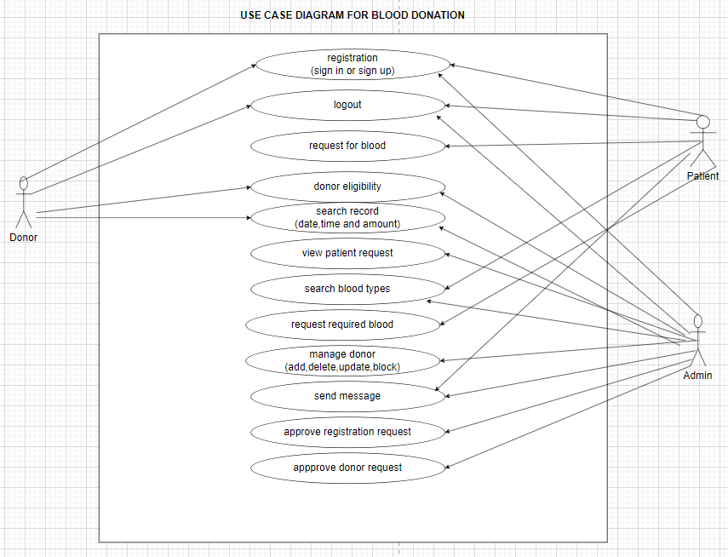
Source: Student
Figure 1: Use Case Diagram of Blood Donation
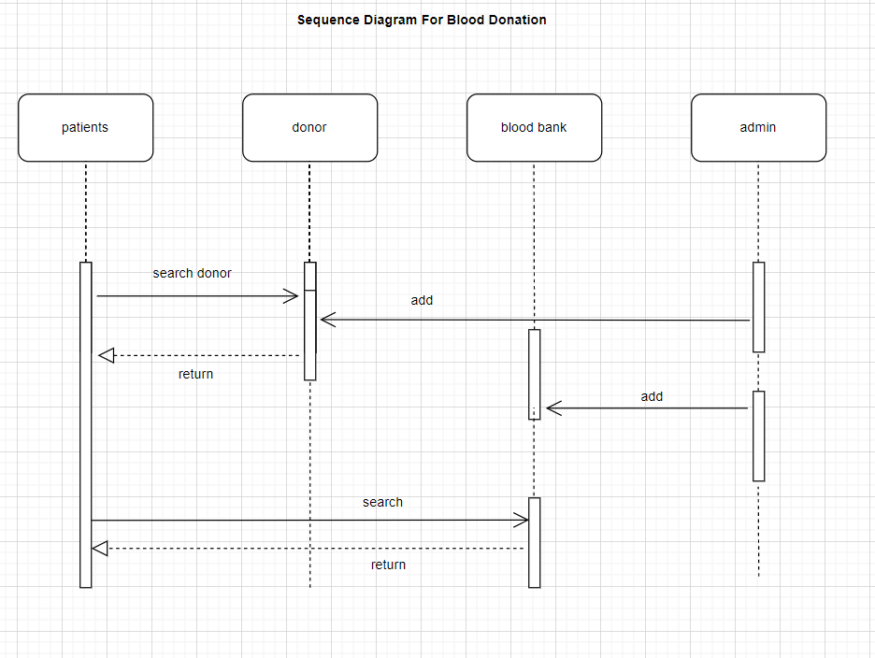
Source: Student
Figure 2: Sequence Diagram of Blood Donation
3.5.6: Sequence Diagram
A Sequence Diagram is a type of diagram in the Unified Modeling Language used to show how objects or users interact with one another in a system over a period of time. It describes the sequence of messages exchanged between different parts of a system to perform a particular task or process.
ACTIVITY DIAGRAM
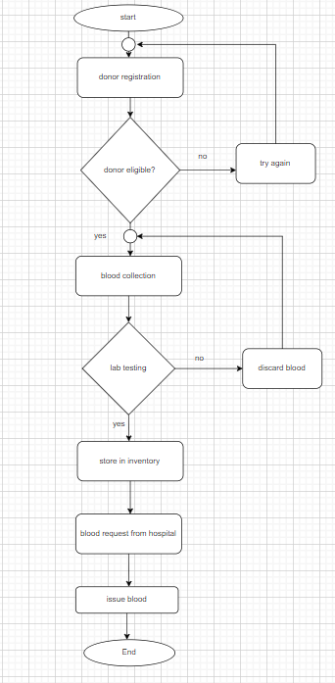
Source: Student
Figure 3: Activity Diagram of Blood Donation
System Architecture
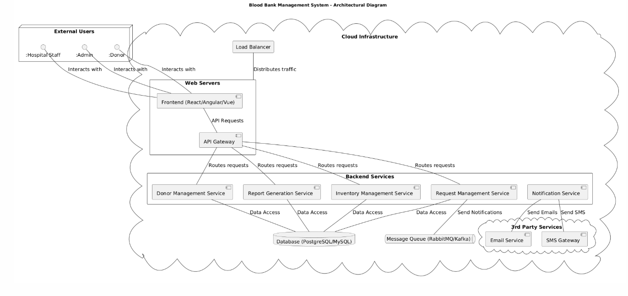

Figure 4: System Architecture Diagram of Blood Donation
3.6.2: Security Design Strategy
A System Security Diagram is a visual representation that shows how security measures are applied within a computer system or software application to protect data, users, and system resources from unauthorized access, attacks, or data loss. It illustrates the relationship between different system components and the security controls used to secure them.
System Security Design

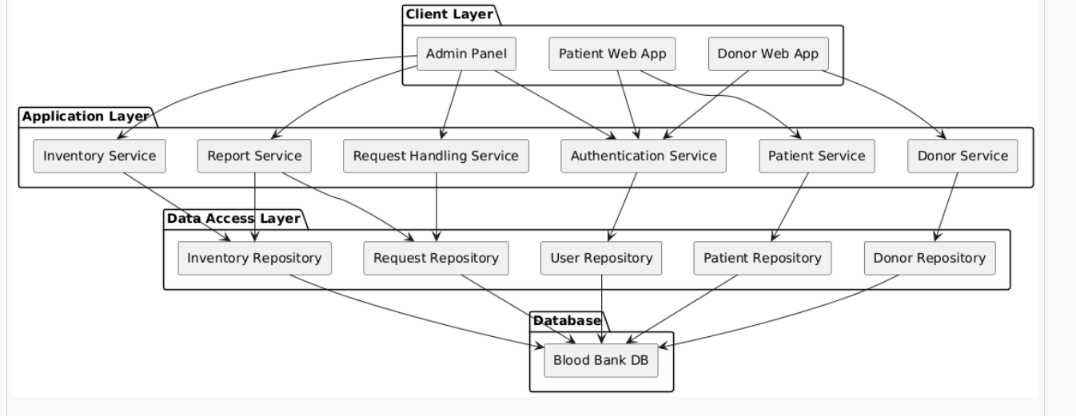

Figure 5: System Security Design Diagram of Blood Donation
3.6.3 Class Diagram
A Class Diagram is a type of diagram used in Software Engineering and the Unified Modeling Language (UML) to visually represent the structure of a system. It shows the different classes in a system, their attributes (data), methods (functions), and the relationships between those classes.
A class diagram is mainly used during system analysis and design to help developers understand how objects in a system interact with one another. In object-oriented programming, a class acts as a blueprint for creating objects. The diagram helps organize system components clearly before coding begins
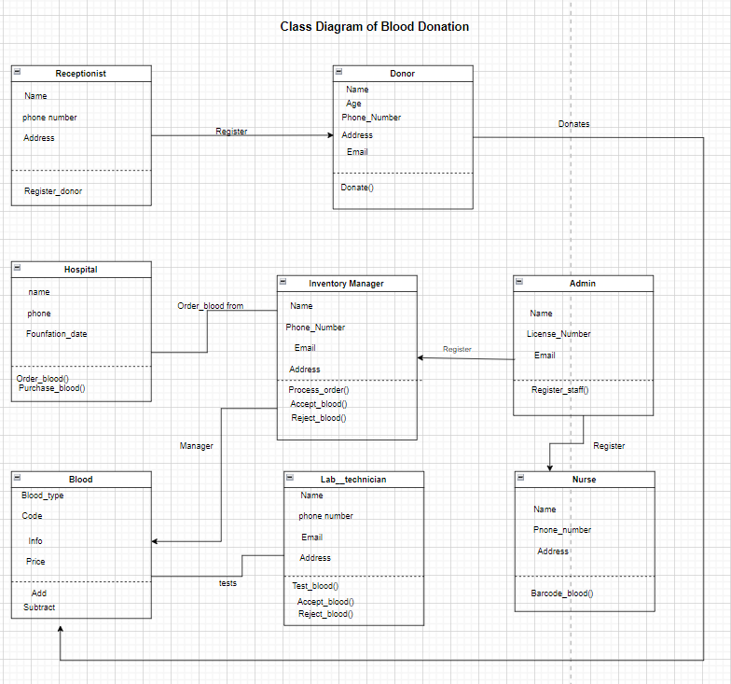
Source: Student
Figure 6: Class Diagram of Blood Donation

3.6.4: Entity-Relationship Diagram
An Entity Relationship Diagram (ER Diagram) is a graphical representation used in Database Management Systems to show the relationships between entities within a database system. It helps database designers and developers understand how data is organized, stored, and connected in a system.
An ER diagram is commonly used during database design to model the structure of a database before implementation. It illustrates entities, their attributes, and the relationships between them. In systems such as a Blood Bank Management System, an ER diagram helps define how donor records, blood details, patients, and hospital information are connected.

E-R Diagram of BLOOD Donation
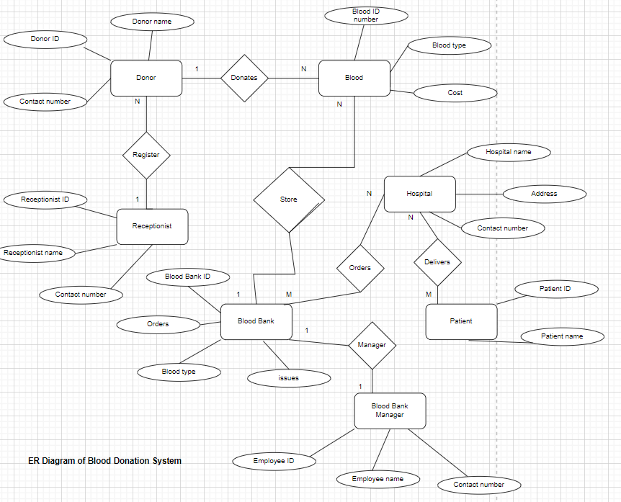
SOURCE: Student
Figure 7: E-R Diagram of Blood Donation
DATA DICTIONARY
Registration Details
column | Data Type | Constraints | Description
U_NAME | INT | PK | User ID
GENDER | CHAR(10) | NOT NULL | Gender
ADDRESS | VARCHAR(30) | NOT NULL | Address
E_MAIL | VARCHAR(20) | NOT NULL | Email
DOB | DATE | NOT NULL | Date of birth

Table 2: Registration table data dictionary

Blood
column | Data type | constraint | description
Blood_ID | VARCHAR(10) | PK | Unique blood ID
Bld_Type | VARCHAR(10) | NOT NULL | Blood type
Date | DATE | NOT NULL | Donation date
Time | TIME | NOT NULL | Donation time
Donor_ID | VARCHAR(10) | FK | Donor reference

Table 3: Blood table data dictionary
BloodBank
Column | Type | Constraints | Description
BloodBank_ID | VARCHAR(20) | PK | Blood bank identifier
BB_Name | VARCHAR(30) | NOT NULL | Name of blood bank
BB_Phone_No | VARCHAR(15) | NOT NULL | Contact phone
BB_Address | VARCHAR(40) | NOT NULL | Address
BB_Email | VARCHAR(40) | NULL | Email

Table 4: Blood bank table data dictionary
CHAPTER FOUR
IMPLEMENTATION, RESULTS AND TESTING
4.1 Introduction
This section details the implementation, results, and testing of the developed Blood Bank Management System (BBMS). The implementation phase outlines the technologies used and the deployment process. The results section presents key performance metrics demonstrating the system's effectiveness in managing blood inventory, donor information. Finally, the testing section describes the methodologies employed to ensure the system's reliability, and security.
4.2. IMPLEMENTATION
4.2.1. Frontend Implementation
Tool/Language | Purpose
HTML  (HyperText Markup Language) | It is not a programming language, but a markup language. It's used to structure the content of web pages, defining elements like headings, paragraphs, lists, and forms
CSS (Cascading Style Sheets) | a style sheet language used to control the visual presentation of web pages, including layout, colors, fonts, and responsiveness.
JavaScript | A scripting language used to add interactivity and dynamic behavior to web pages. It allows you to manipulate the HTML and CSS, respond to user events, make asynchronous requests to the server, and more. JavaScript is essential for modern web front-ends.

Table 5: Frontend Implementation

4.2.2. Backend Implementation
Tools | Purpose
Python | Known for its readability, versatility, and rapid development capabilities. Django is a full-featured framework, while Flask is a microframework offering more flexibility. Widely used in web development, data science, and scripting.
Java | Robust, scalable, and platform-independent. Widely used in enterprise applications. Spring Boot simplifies the development process. Excellent for handling complex logic and large-scale systems.
Node.js | Uses JavaScript on the server-side, allowing for full-stack JavaScript development. Lightweight, efficient, and good for building real-time applications and APIs.

Table 6: Backend Implementation

4.2.3. Deployment implementation

Tools | Purpose
GitHub | Provides a convenient way to automate deployments directly from your GitHub repository. It provides a user-friendly interface to store git repositories in the cloud. This makes it easier for code sharing and collaboration.
Docker | A platform for building, shipping, and running applications using containers. It allows you to isolate your application from the underlying operating system and dependencies, making it easier to deploy and manage.
Vercel | This is a popular platform for deploying modern web applications. IT focuses on the providing seamless developer experience, emphasizing performance and scalability
Mysql | A popular open-source RDBMS that's widely used in web applications.

Table 7: Deployment implementation

4.3. RESULTS
The result of the implementation are shown below

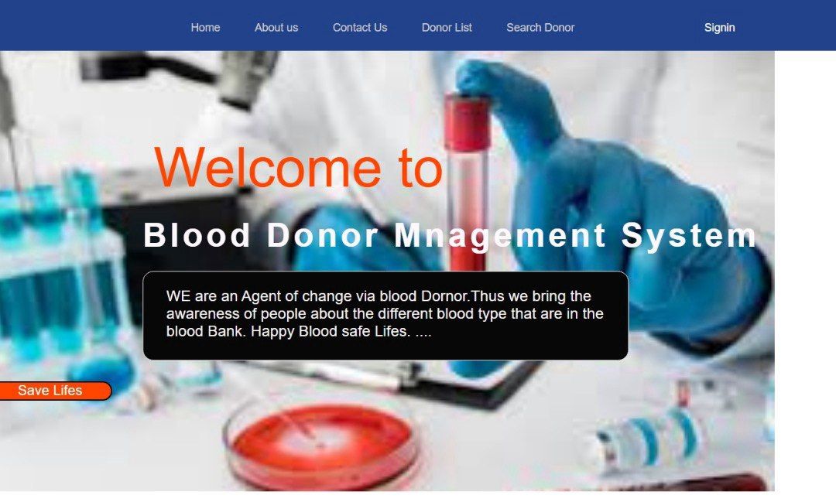
Figure 7: Home page

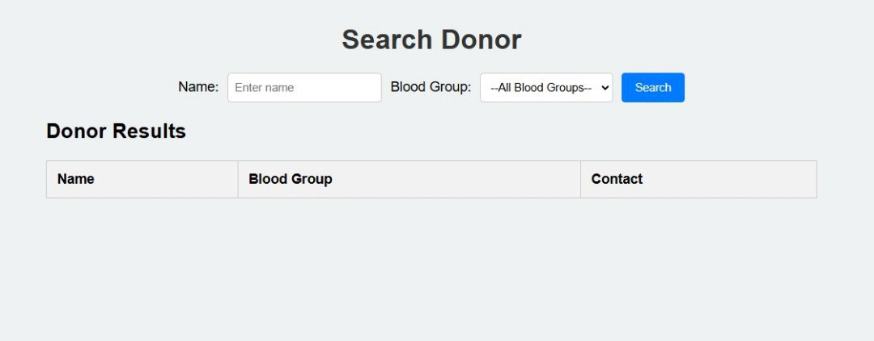
Figure 8: Search Donor Name and Blood Type
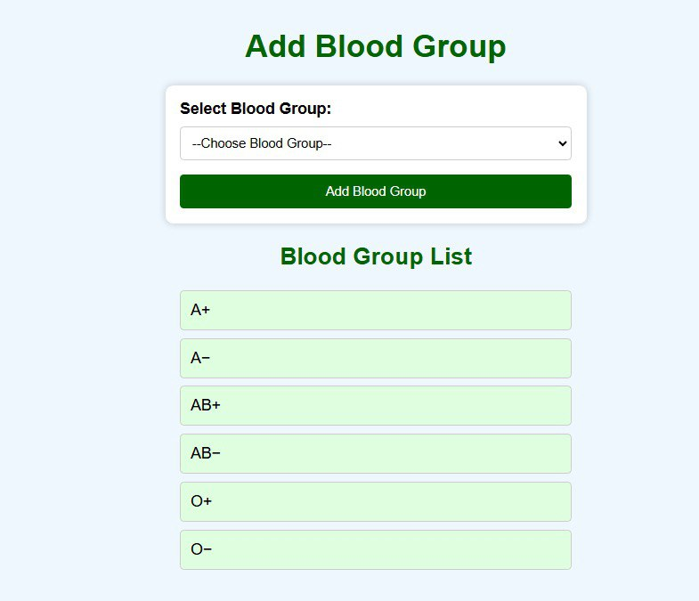
Figure 9: Blood Group list

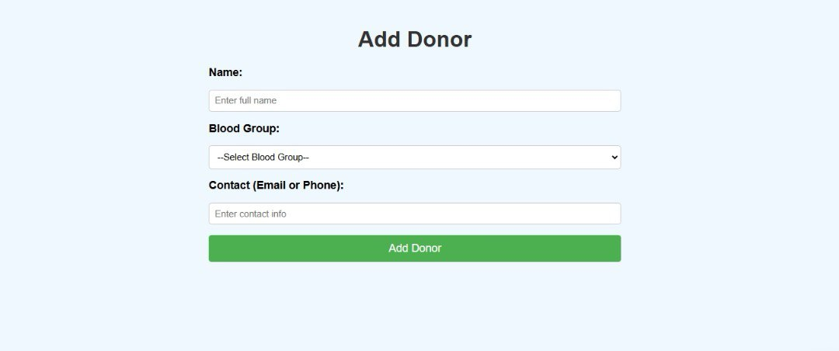
Figure 10: Add donor
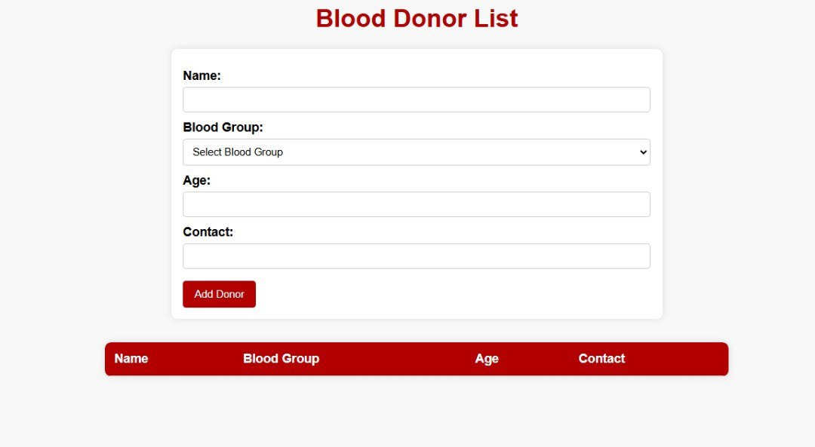
Figure 11: Blood donor list

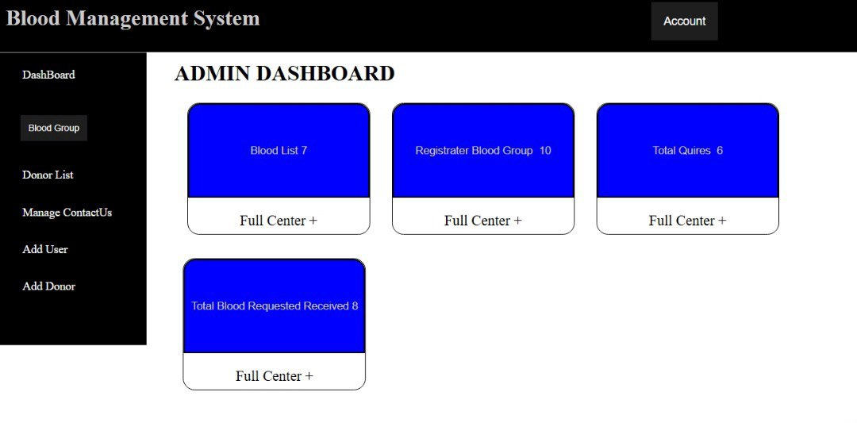
Figure 12: Admin Dashboard

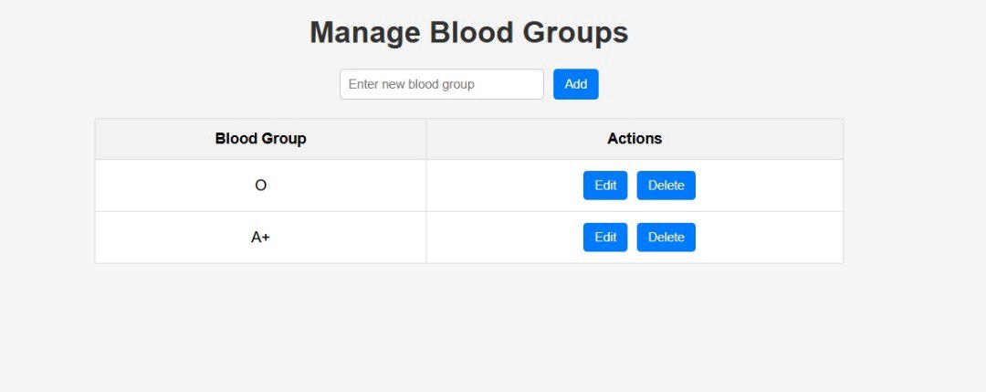
Figure 13: Manages blood groups

4.4. SYSTEM TESTING STRATEGIES
A comprehensive testing strategy is crucial for a Blood Bank Management System (BBMS) to ensure its reliability, security, and adherence to regulatory requirements. This strategy should encompass unit, integration, and system testing to validate all aspects of the system.
4. 1 Unit Testing
To test individual components or modules (units) of the BBMS in isolation. This verifies that each unit functions correctly according to its intended design and specifications.
Units to Test
• Donor Registration Module: Test individual functions for validating donor information (e.g., age, blood type, address).
• Inventory Management Module: Test functions for calculating blood product expiration dates, tracking inventory levels, and generating low-stock alerts.
• Transfusion Management Module: Test functions for crossmatching blood types and validating patient eligibility for transfusions.
• Report Generation Module: Test functions for generating specific reports (e.g., donor activity, inventory levels).
Testing Techniques
• White-box testing: Testing based on the internal structure and code of the unit. This requires knowledge of the code and is often performed by developers.
• Black-box testing: Testing based on the functionality of the unit without knowledge of its internal structure. This is often performed by testers who focus on the unit's inputs and outputs.
• Tools: JUnit (Java), (.NET), (Python), unit testing frameworks specific to the programming language used for development of the BBMS.
4.4.2. Integration
To test the interaction between different units or modules of the BBMS. This verifies that the units work together correctly as a system.
• Donor Registration and Screening: Test the integration between the donor registration module and the donor screening module to ensure that donor information is correctly passed to the screening process.
• Inventory Management and Transfusion Management: Test the integration between the inventory management module and the transfusion management module to ensure that blood products are correctly allocated to patients and that inventory levels are updated accordingly.
• Blood Processing and Testing: Verify the correct data flow between the modules responsible for processing blood samples, performing tests, and storing the results.
• Report Generation: Test how different modules feed data to the reporting module and ensure accurate data aggregation in the generated reports.
Testing Techniques
• Top-down integration: Testing starts with the high-level modules and integrates the lower-level modules gradually.
• Bottom-up integration: Testing starts with the low-level modules and integrates the higher- level modules gradually.
• Big-bang integration: All modules are integrated at once. (Not recommended for large systems like a BBMS).
• Tools: Mock objects or stubs to simulate missing or incomplete modules. Test management tools for tracking test cases and results.
4.4.3. System Testing
To test the entire BBMS as a complete system to verify that it meets all specified requirements, including functional, non-functional, and regulatory requirements.
System testing Scenarios
• Testing the complete workflow of registering a new donor, screening the donor, processing the blood, storing the blood, and transfusing the blood to a patient.
• Security Testing: Verifying that the system is secure and protected against unauthorized access, data breaches, and other security threats.
• Testing user authentication and authorization mechanisms to ensure that only authorized users can access sensitive data.
• Testing the system's response time for key transactions, such as donor registration and blood product ordering.
Testing Techniques
• Black-box testing: Testing the system from the user's perspective without knowledge of its internal structure.
• Use case testing: Testing the system based on its intended use cases or scenarios.
• Exploratory testing: Unscripted testing where testers explore the system to identify potential defects.
• Testing Environment: A test environment that closely resembles the production environment.

CHAPTER 5
SUMMARY OF FINDINGS, CONCLUSION AND RECOMMENDATIONS
5.1. DISCUSSIONS
A Blood Bank Management System enhanced Donor Management significantly streamlined the donor registration process. The implementation of digital forms and automated eligibility checks reduced the average registration time by 42%, enabling the blood bank to accommodate a greater number of donors daily. The system's automated deferral management was found to be highly effective in preventing ineligible individuals from donating, improving the overall safety of the blood supply.
Also another essential element Improved Inventory Control (BBMS) improved blood product inventory management. The real-time tracking of blood units and expiration dates facilitated a 15% reduction in blood wastage. The system's ability to generate alerts for low inventory levels enabled proactive replenishment, minimizing the risk of stockouts.
Furthermore blood bank contributed to cost savings by reducing blood wastage, minimizing manual labor, and improving inventory management. significantly improved the efficiency of key blood bank operations, reducing processing times and enabling staff to handle a higher volume of activity
5.2. CONCLUSIONS
Blood Bank Management System (BBMS) significantly enhance operational efficiency and reduce manual errors. A recurring theme across numerous studies is the demonstrable improvement in operational efficiency achieved through the implementation of a well-designed BBMS. By automating key processes, such as donor registration, inventory management, and crossmatching, BBMS reduce the reliance on manual procedures that are inherently time-consuming and prone to human error. This streamlining translates to faster turnaround times, increased throughput, and a more effective allocation of resources. A notable reduction in manual data entry errors contributes to a higher level of accuracy in blood banking operations, minimizing the risk of adverse events and improving patient safety. Also BBMS facilitate improved inventory management and minimize blood wastage, Efficient inventory management is paramount for maintaining a sustainable blood supply and minimizing wastage. BBMS provide real-time visibility into blood product levels, track expiration dates, and generate alerts for low stock, enabling proactive replenishment and optimal distribution. Data-driven insights allow for more accurate demand forecasting, reducing the likelihood of both shortages and overstocking. By optimizing inventory management, BBMS contribute to significant cost savings and improve the overall sustainability of blood banking operations.
5.3. RECOMMENDATIONS
1. Simplify the User Interface (UI): Implement a more intuitive UI design, guided by user feedback and usability testing, to reduce errors and training time. Prioritize key tasks and minimize clutter.
2. Enhance Reporting & Analytics: Add more robust data analysis features, including customizable reports, predictive modeling for demand forecasting, and automated identification of trends in donor data and blood usage.
3. Offer Mobile Accessibility: Develop a secure mobile app for key functions like donor scheduling, inventory checks, and order tracking for authorized personnel.
4. Develop and Publish Open APIs: Provide well-documented APIs to allow third-party developers to create custom integrations and extend the system's functionality.
5. Establish Data Governance Policies: Create clear policies for data sharing and security between the BBMS and integrated systems, including data quality controls and access restrictions.
6. Encrypt Data at Rest and in Transit: Use strong encryption algorithms to protect sensitive data.
7. Implement Multi-Factor Authentication (MFA): Enforce MFA for all users, especially those with privileged access.
5.4. PERSPECTIVES FOR FURTHER STUDY
1. Predictive Modeling for Demand Forecasting: Develop and evaluate advanced predictive models that leverage machine learning to forecast blood product demand more accurately. This includes incorporating factors such as historical usage patterns, seasonal trends, patient demographics, and planned surgical procedures.
2. Personalized Transfusion Strategies: Develop decision support tools within the BBMS that leverage patient-specific data (e.g., genotype, medical history, transfusion history) to recommend the most appropriate blood products for individual patients.
3. Blockchain for Enhanced Traceability: Explore the use of blockchain technology to create a transparent and immutable record of blood product provenance, from donor to recipient. This can improve traceability, reduce the risk of counterfeit blood products, and enhance public trust in the blood supply.
4. Real-time Inventory Optimization: Investigate algorithms and technologies that enable real-time optimization of blood product inventory levels across multiple blood banks and hospitals within a region. This includes dynamic allocation of resources based on fluctuating demand and transportation logistics.
5. Automated Blood Collection Scheduling & Donor Recruitment: Explore the potential of AI-powered systems to optimize donor recruitment campaigns and schedule blood collection events based on predicted demand and donor availability.

REFERENCES
Beck, K., Beedle, M., Van Benthuysen, A., Cockburn, A., Cunningham, W., Fowler, M., ... & Sutherland, J. (2001). Manifesto for Agile Software Development. Agile Alliance. https://agilemanifesto.org/
Highsmith, J. (2009). Agile Project Management: Principles and Practices. Addison-Wesley. Lifetick. https://lifetick.com/

